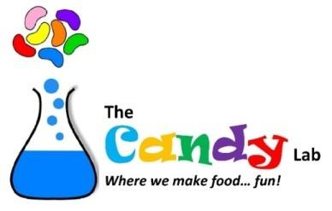
My promise to you:
Our goal is to nurture children’s imagination and foster their artistic abilities through creative expression.
The Candy Lab offers the opportunity to learn a new skill by gaining hands-on experience and developing fine motor skills.
We offer a safe space where kids can interact with their peers, share ideas and collaborate on projects. This helps to build confidence, communication skills and teamwork abilities in children.
When children work with their peers, they spend quality time together in a fun and constructive environment.
Crafters are proud to share their completed artwork with their parents. This provides a sense of accomplishment and serves as a memento of their creative efforts.
We provide a refreshing break from technology where children can explore their creativity in a screen-free environment.
The Candy Lab provides a safe and supervised space for children to explore and create under the guidance of experienced instructors.
The Candy Lab offers a diverse range of crafts and projects that highlight creativity and innovation. This ensures that our crafters remain engaged and excited about attending our sessions.
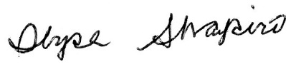
Ilyse Shapiro, Chief Confectionery Officer, The Candy Lab
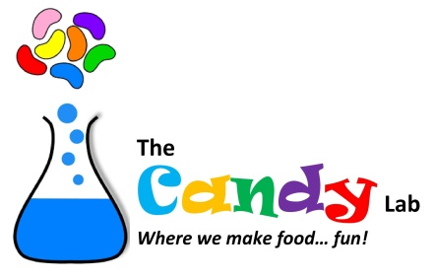
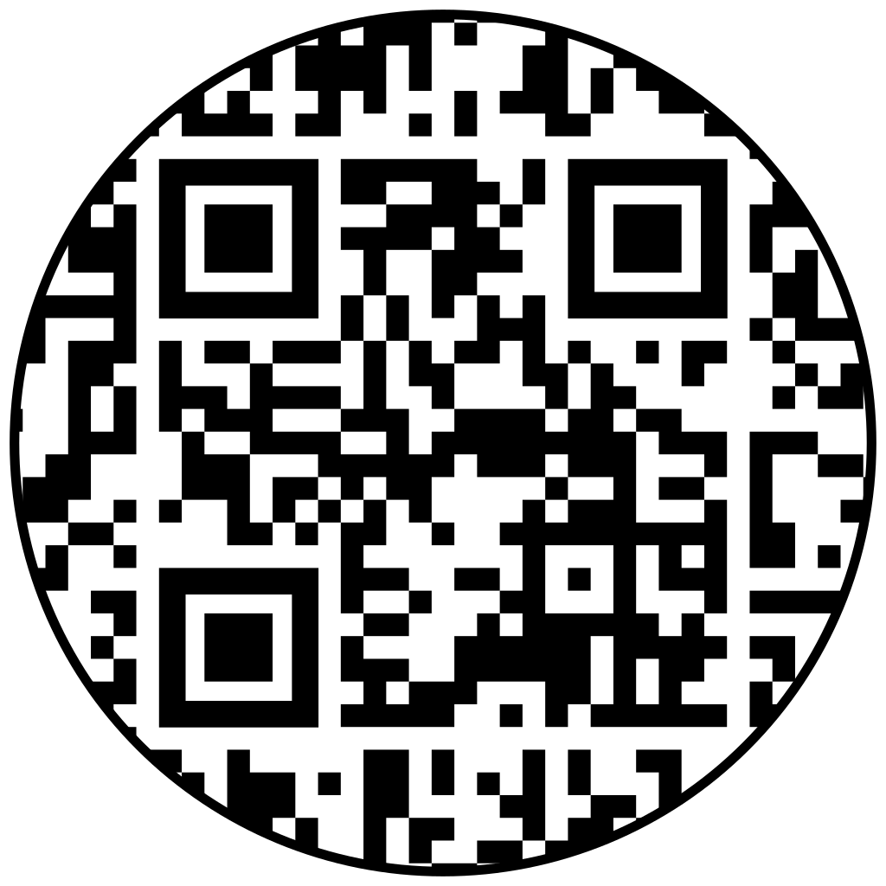
The Candy Lab Party Packages
 | Ultimate Party | Sweetest Party | Confectioner’s Party | Bon Bon Party
Total Time of Event | 120 minutes | 90 minutes | 75 minutes | 60 minutes
Crafting Time | 75-90 minutes | 60 minutes | 45 minutes | 60 minutes
Party Time | 30-45 minutes | 30 minutes | 30 minutes | 0 minutes
Edible Crafts | 8 | 6 | 4 | 4
Party comes with all crafting supplies, staff*, set-up and clean up | Yes | Yes | Yes | Yes
For ages | 4-6 | 6-8 | 9+ | Any age
Cake and pizza may be added at an additional cost (or bring your own) | Yes | Yes | Yes | No
Minimum Amount of Guests | 8 | 8 | 10 | 10
Cost | $55 per crafter | $45 per crafter | $35 per crafter | $30 per crafter
Optional: Add Goodie bag for each crafter | $5 each | $5 each | $5 each | $5 each
Optional: Add Toque/Apron for each crafter | $10 each | $10 each | $10 each | $10 each
Optional: Add Candy Salad | $25 per 10 crafters | $25 per 10 crafters | $25 per 10 crafters | $25 per 10 crafters

*Add an extra $50 if guest count is over 15 crafters. Add an additional $150 for parties away from Lab.
Call with questions or to reserve: (610) 639-9460 or email: ilyse@theCandyLaboratory.com

Haverford Ave., Narberth, PA * 104 Walnut St., Haddonfield, NJ

Abington Art Center: 515 Meetinghouse Rd, Jenkintown

